COMTRUST ACADEMY OF
RESEARCH AND TRAINING
(COMTRUST EYE HOSPITAL)

Puthiyara, Calicut – 673 004
Phone:2721620, 2727942, 2723793, Fax:0945-2725050
E-mail: koz_comeye@sancharnet.net.in, admin@comtrusteyehospital.org
Website:www.comtrusteyehospital.org
PROSPECTUS
FOR ADMISSION TO DNB COURSE
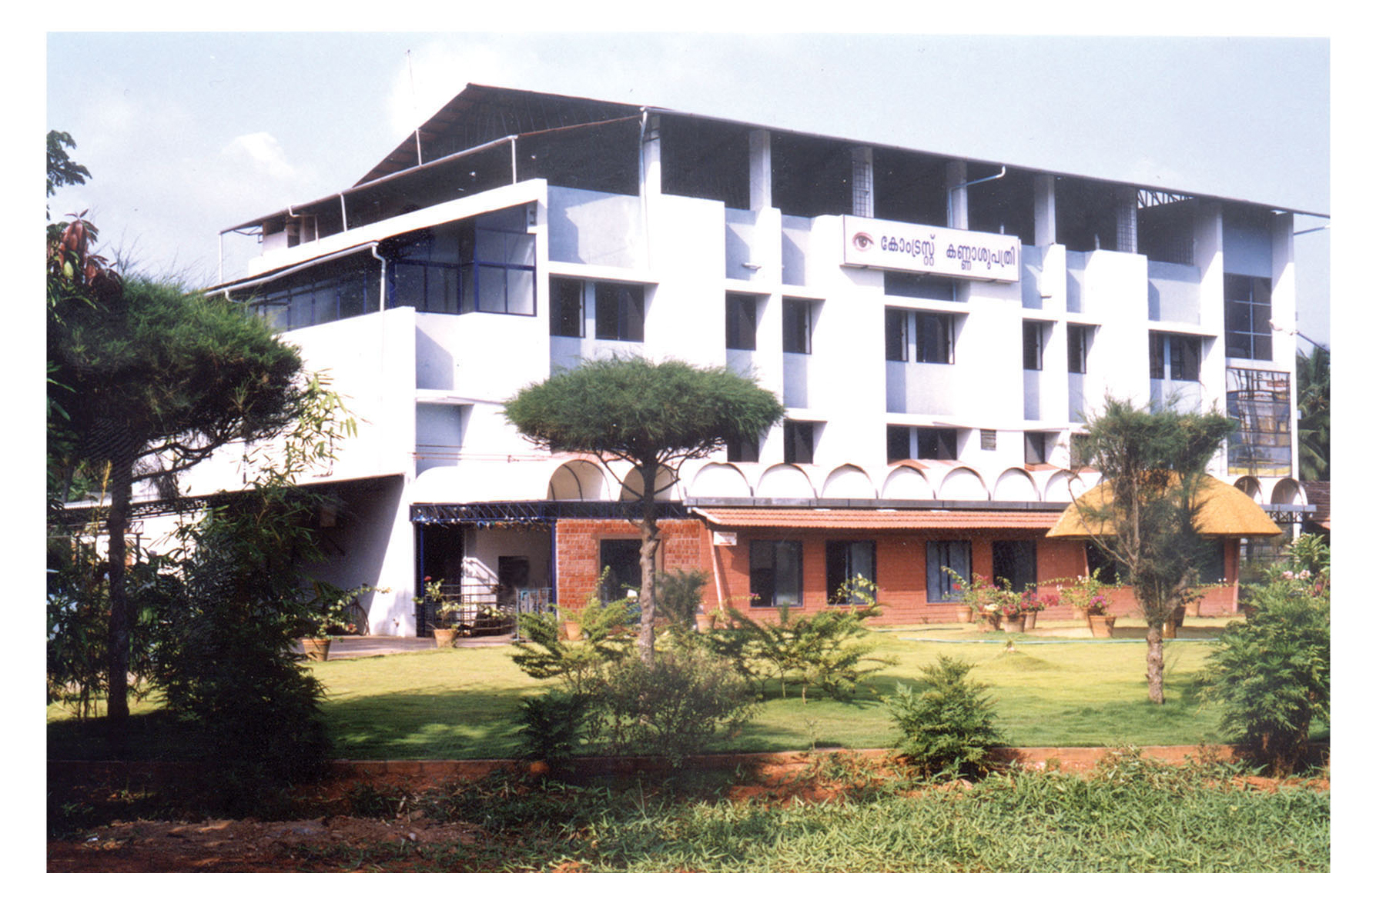

-2-
INTRODUCTION
COMTRUST ACADEMY OF RESEARCH AND TRAINING is a subsidiary unit of Comtrust Eye Hospital, Calicut. Comtrust Eye Hospital was established in 1999 to provide quality eye care to the people of Malabar and is owned by the Comtrust Charitable Trust, a Regd. Public Charitable Trust of repute working from Calicut city for last many years.
The Academy was started in 2004 with the sole aim of training students and conducting research using the facilities available at the Hospital. With this aim, certain academic courses were planned.
The Hospital is well equipped with sophisticated modern equipments and has a team of highly qualified doctors and dedicated paramedical staff. If runs Speciality Clinics in Cataract, Retina, Glaucoma, Uvea, Paediatric Ophthalmology, Squint and Contact Lens. Trainees will be exposed to modern techniques of eye examination, all ophthalmic surgeries under supervision of well experienced consultants and visiting consultants.
The National Board of' Examinations, New Delhi has recognized the Hospital for conducting DNB Course in Ophthalmology from January, 2007.
COURSE & NO. OF SEATS
During the current year one seat is available for primary candidates who have passed Primary Examination conducted by National Board &' one seat for those who have passed DO Course.
DURATION OF THE COURSE
3 - Years for primary candidates. 2- Years for diploma holders.
ELIGIBILITY FOR ADMISSION
Primary candidates who have passed Primary Examination conducted by National Board. One seat is for the candidate who has passed Diploma in the Speciality which is recognized by MCI / University.
FACILITIES FOR THE CANDIDATES UNDERGOING THE COURSE
30% of the Hospital beds are reserved for DNB trainees under the supervision of Consultants for investigation and surgical procedures. The Hospital is having an average of 450 patients daily in the OP and is conducting over 700 surgeries per month. (In Free Section and Payment Section, together)
SELECTION PROCESS
No written examination. Selection is done only through an Aptitude / Objective assessment.
STIPEND / REMUNERATION
The Hospital will pay each trainee (both Post MBBS &, Post Diploma) a minimum monthly stipend equivalent to the sum paid to MD/MS/DM/MCH trainees by Kerala State Govt., in institutions owned by them, or, as mentioned below, whichever is HIGHER:-
Programme | First year | Second year | Third year
Broad Specialities | Rs: 18,500 | Rs: 18,500 | Rs: 18,500

-3-

-4-
LEAVE FOR DNB TRAINEES
“15" - days in a year. Sunday camp duty, by turn.
LIBRARY FACILITIES
A well equipped library is available at this Hospital. Sufficient Journals as per guide lines, are also available.
TRAINING IN BASIC SCIENCES
Daily teaching programmes are arranged. Training in Basic Sciences are- also arranged by expert Faculty Members of Hospital as well as through Guest Faculty.
ASSESSMENT OF TRAINEES
Proper assessment in theory knowledge, clinical experience and surgical skill are scheduled.
TRAINING CHARGES (As per guidelines of National Board)
- Tuition fees
- Library fees
- Internet fees
- Guest Lectures, Seminar/Conference fees
- Six monthly Theory & Practical Exam fees
Rs- 15,000 Rs: 5,000 Rs: 10,000 Rs: 10,000 Rs: 10,000
-5-
APPLICATION FORM
The Application form can be obtained from the Director, (Research and Training), Comtrust Eye Hospital, Puthiya, Calicut - 673 004 . Free of Cost during office hours. Candidates who wants application to be mailed to there contact the Director over phone at the earliest.
CERTIFICATES TO BE PROVIDED ALONG WITH THE APPLICATION FORM
Candidates are required to provide attested copies of the following-
- SSLC
- Pre Degree / +2
- M. B. B. S
- Primary Exam /GET.
- D.O. Certificate, if passed.
- A self addressed envelope.
CAPITATION FEE / SECURITY DEPOSIT
There: will be NO Capitation Fee or Security Deposit or-such levy payable by the selected Candidate.
ACCOMMODATION
Rent free accommodation will be provided in CALICUT City for the selected Candidates by the Hospital.

